Exploring the Synergies between Artificial Intelligence and Blockchain for Enhanced Cybersecurity

1Suman Garai, 2Dr. Sanjeev Kumar Mandal

1Student, 2Assistant Professor

Department of Computer Science & IT,

Jain Deemed-to-be-University, Bengaluru, India

________________________________________________________________________________________________________

***Abstract:*** The integration of Artificial Intelligence (AI) and Blockchain technology has been a topic of growing interest in recent years. The unique properties of these two technologies have the potential to provide solutions for several security-related challenges in the digital world, with applications in various domains such as finance, healthcare, and cybersecurity. This paper focuses on the role of AI in Blockchain and cybersecurity and how these two technologies can complement each other to enhance the overall security of digital systems. We review the fundamentals of AI and Blockchain technology including their respective definitions, principles, and applications. Thereafter, we examine the potential benefits of combining AI and Blockchain in the context of cybersecurity, including improved threat detection, secure and transparent data storage, and enhanced privacy protection. We then explore the existing and emerging solutions that use AI and Blockchain to enhance cybersecurity, such as AI-powered smart contracts, decentralized identity management, and AI-powered intrusion detection systems. The paper concludes by highlighting the current challenges and limitations of AI-Blockchain integration and the need for further research in this area. The results of this study are expected to provide insights and guidance for researchers, practitioners, and policymakers who are interested in exploring the synergies between AI and Blockchain for enhanced cybersecurity.

*IndexTerms*— Threat detection, Data protection, Cyber threats, Machine learning, Privacy, Transparency, Trust, Decentralization.

*________________________________________________________________________________________________________*

# **Introduction**

The world is undergoing a digital transformation, and the increasing use of technology has led to the creation of new opportunities and challenges. One of the major challenges faced by the digital world is cybersecurity, as the digital systems and data are vulnerable to attacks and threats from malicious actors. The rise of cyber threats, such as hacking and fraud, has made it imperative to develop and implement innovative security solutions that can effectively protect against these malicious activities. Artificial Intelligence (AI) and Blockchain technology have emerged as two of the most promising technologies in this regard, offering unique properties and capabilities that can be leveraged to enhance the security of digital systems and data. The integration of AI and Blockchain can bring about a new era of digital transformation, with applications in various domains such as finance, healthcare, and cybersecurity. This paper explores the synergies between AI and Blockchain for enhanced cybersecurity.[1]

Artificial Intelligence (AI) and Blockchain technology, along with Cybersecurity, are rapidly growing fields that are changing the digital landscape. AI involves the development of computer systems that can perform tasks that require human intelligence, such as image recognition, speech recognition, and natural language processing. Blockchain is a decentralized, secure, and transparent technology for storing and transferring data, using a distributed ledger system and smart contracts. Cybersecurity refers to the protection of digital systems and data against unauthorized access, theft, or damage, and is a critical concern due to the increasing amount of sensitive information being stored and transferred online.

The integration of AI and Blockchain offers several potential benefits in terms of cybersecurity. AI algorithms can be used to analyze large amounts of data in real-time and detect patterns that indicate potential cyber threats, detect and prevent malicious activities, such as hacking and fraud, in real-time. Blockchain-based solutions can ensure secure and transparent data storage and transfer, preventing unauthorized access and tampering. Additionally, blockchain can provide a secure platform for AI algorithms to operate on, adding an extra layer of security and trust. The use of AI-powered smart contracts can also provide additional security to the execution of contractual agreements in a decentralized manner. This integration is expected to bring about a new era of digital transformation, with applications in various domains such as finance, healthcare, and cybersecurity.[2]

Despite the potential benefits of AI-Blockchain integration, there are several challenges and limitations that need to be addressed. The integration of AI and Blockchain in cybersecurity offers new solutions, but it also faces challenges, including secure and efficient data storage and transfer, effective and secure algorithms, and ensuring transparency, fairness, and trust in AI-Blockchain systems. A comprehensive framework must be developed to address these challenges and ensure the success of AI-Blockchain integration in cybersecurity.

The integration of AI and Blockchain technology has the potential to bring about significant advancements in the field of cybersecurity. While there are several challenges and limitations that need to be addressed, the combination of these technologies offers new solutions for protecting digital systems and data against threats. By addressing these challenges, the integration of AI and Blockchain technology can enhance the overall security of the digital landscape and bring about a new era of digital transformation.[3]

# **Digital Security Risks In Recent Times**

The severity and quantity of cybersecurity threats have significantly increased in recent years, leading to substantial financial losses and harm to the reputation of many businesses. Regrettably, the seriousness of these threats is demonstrated by several real-life examples.

Supply chain attacks are a form of cyberattack that involves compromising a third-party supplier to gain access to a target's systems. Notable cases include the 2020 SolarWinds attack, in which Russian hackers infiltrated the software provider's update process to gain entry into thousands of organizations' networks. The SolarWinds attack has raised concerns about the security of the global supply chain and the potential for nation-state actors to use such tactics to gain access to sensitive information.

Another kind of cyberattack is IoT attacks, which involve exploiting vulnerabilities in Internet of Things devices to access networks and systems. The 2016 Mirai botnet attack is a famous example. It used compromised IoT devices to launch a massive DDoS attack that disrupted internet service across the eastern United States.

Advanced Persistent Threats (APTs) are a type of cyberattack in which unauthorized users gain access to a system and remain undetected for an extended period, usually with the intention of stealing sensitive data or perpetrating other attacks. In 2015, the U.S. government revealed that Chinese hackers had carried out a large-scale APT against the U.S. Office of Personnel Management, compromising the personal data of over 21 million individuals.

Ransomware attacks: These attacks involve a malicious actor encrypting a victim's data and demanding payment in exchange for the decryption key. Notable examples include the WannaCry attack of 2017, which affected more than 300,000 computers in 150 countries, by exploiting a vulnerability in Microsoft Windows and demanded payment in Bitcoin in exchange for unlocking encrypted files, and the Colonial Pipeline attack in 2021, which disrupted fuel supplies across the eastern United States.

Social engineering is a technique used by cybercriminals to manipulate individuals into revealing sensitive information or taking action that could compromise their security. A phishing attack is one example, in which an attacker poses as a legitimate entity (such as a bank or other institution) to deceive the victim into revealing login credentials or other sensitive information. One notable example of a social engineering attack occurred in 2017, when attackers were able to compromise the email accounts of employees at the U.S. Securities and Exchange Commission (SEC). The attackers then used the compromised accounts to obtain non-public information about publicly traded companies and used that information to conduct insider trading. The attackers used a phishing email that appeared to be from a colleague in order to trick the employees into divulging their login credentials.

Distributed Denial of Service (DDoS) attacks overwhelm a server or network with a flood of traffic to render it unusable. In 2016, the Mirai botnet caused a massive DDoS attack against internet infrastructure provider Dyn, resulting in significant outages for several popular websites. The attack is estimated to have caused up to $110 million in damages, highlighting the significant impact that DDoS attacks can have on companies and their customers.

Account takeovers are on the rise and can affect individuals as well as large organizations. In an account takeover attack, hackers gain access to a person or organization's account by stealing their login credentials or exploiting system vulnerabilities. Once they gain access, they can use the account to steal sensitive data or launch phishing attacks on other users. In 2019, Capital One, a credit card company, experienced a major account takeover attack that impacted millions of users. The hacker was able to access the personal data of approximately 100 million people in the United States and Canada, including social security numbers, credit scores, and bank account numbers. Capital One was fined $80 million for not preventing the attack.

Credential theft is a common tactic used by attackers to gain access to sensitive information or systems. In this type of attack, the hacker steals the user's login credentials, such as usernames and passwords, and uses them to access the victim's account or system. In 2018, Marriott International, a hotel chain, experienced a massive data breach that exposed the personal information of roughly 500 million guests. The hacker was able to access Marriott's reservation system by stealing login credentials from a third-party vendor. The breach resulted in Marriott being fined $123 million.

Malicious insiders are individuals who have authorized access to an organization's systems and data but use that access for harmful purposes. These individuals could be employees, contractors, or other authorized personnel who have the knowledge and access to carry out the attack. In 2019, a former Tesla employee was charged with stealing confidential information and intellectual property from the company's system. The employee had access to the company's systems and had copied over 300,000 files to his personal account. The attack is estimated to have cost Tesla millions of dollars in damages.

The Stuxnet worm is a notable example of a zero-day attack, which is when an attacker exploits a previously unknown vulnerability in software. It targeted industrial control systems, exploiting several zero-day vulnerabilities in Windows and Siemens software to modify programmable logic controllers and cause them to malfunction, potentially leading to physical damage. The attack is believed to have been carried out by a nation-state actor and has had significant implications for the development of cyber weapons and the use of zero-day exploits in warfare.[4]

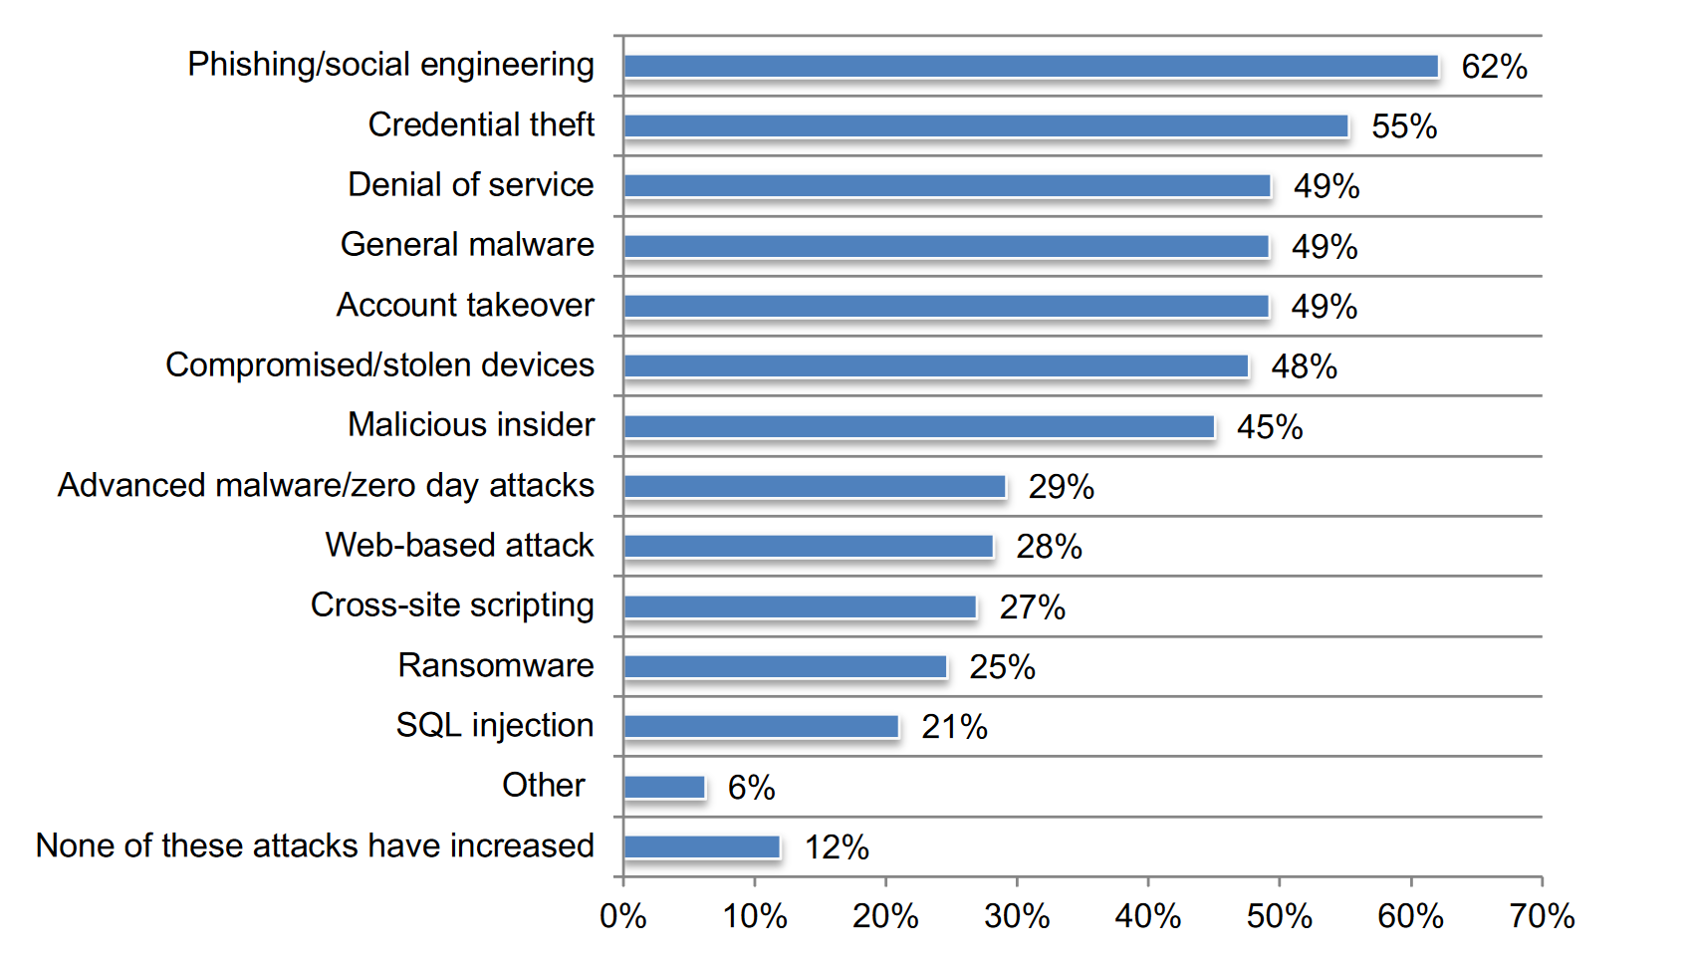**Figure 2.1:** A Survey Report stating Increase in Different Kinds of Cyberthreats since COVID-19.[5]

These examples show the devastating financial and reputational consequences that cybersecurity attacks can have. Companies may face legal sanctions, loss of customers, and significant damage to their brand reputation. Additionally, society as a whole may suffer from the loss of sensitive information, disruptions to critical infrastructure, and an increased risk of identity theft and fraud. In light of these risks, organizations must take cybersecurity seriously and invest in robust security measures to safeguard their systems and data.

# **Current Measures for Protection Against Cyber Threats**

The field of cybersecurity is constantly changing, which necessitates ongoing improvements and adjustments to address new threats. Companies and organizations implement a variety of measures and strategies to safeguard their systems and data as part of their cybersecurity efforts. In the following section, we will examine some of the existing cybersecurity measures, along with real-life examples, and consider their significance for businesses and society.

One of the most critical aspects of maintaining cybersecurity is having a robust and comprehensive cybersecurity framework. A cybersecurity framework outlines the policies, procedures, and controls that an organization should implement to manage and reduce cybersecurity risks. One of the widely adopted cybersecurity frameworks is the NIST Cybersecurity Framework. It is a voluntary framework that provides a common language and methodology to manage and reduce cybersecurity risks. The framework consists of five core functions: Identify, Protect, Detect, Respond, and Recover. By implementing the NIST Cybersecurity Framework, organizations can improve their ability to manage cybersecurity risks and prevent potential cyberattacks.

Another essential measure in maintaining cybersecurity is implementing IT governance. IT governance is a framework that aligns IT strategy with business strategy, provides clear accountability, and ensures the effective and efficient use of IT resources. It includes developing policies, procedures, and guidelines that establish how technology is used and managed within an organization. By implementing effective IT governance, organizations can reduce the risk of cyberattacks and minimize the impact of any security breaches.[6]

In addition to having a cybersecurity framework and effective IT governance, organizations also use Security Information and Event Management (SIEM) solutions to maintain cybersecurity. SIEM solutions are security management tools that collect and analyze security-related data from multiple sources in real-time to identify security threats. They provide a centralized view of an organization's security posture and enable quick responses to security incidents. By using SIEM solutions, organizations can detect and respond to security incidents more efficiently and effectively, minimizing the impact of a cyberattack.

Disaster recovery mechanisms are also crucial in maintaining cybersecurity. Disaster recovery refers to the process of restoring systems and data after a security breach or other catastrophic event. It involves implementing measures such as backup and recovery solutions, offsite data storage, and business continuity plans. By having a disaster recovery plan in place, organizations can minimize the downtime caused by a security breach and ensure that essential business operations can continue.

In addition to cybersecurity frameworks, IT governance, SIEM, and disaster recovery mechanisms, there are a number of other measures that are being taken by companies and individuals to protect themselves from cyber threats. One of the most important measures is education. Educating individuals about cyber threats and how to protect themselves is crucial to preventing attacks. Many companies provide training and education programs for their employees to ensure that they are aware of the latest threats and know how to respond to them. Some organizations offer training programs, workshops, and seminars to help raise awareness about cyber threats and how to prevent them. For example, the National Cyber Security Centre (NCSC) in the UK provides guidance on how to stay safe online, including a range of educational resources that can help individuals and businesses to improve their cybersecurity practices.

Governments around the world have recognized the need for stronger cybersecurity laws and regulations to address the increasing threat of cybercrime. These laws are designed to protect individuals and businesses from cyber-attacks and establish legal frameworks for prosecuting cyber criminals. For example, the European Union’s General Data Protection Regulation (GDPR)[7] sets standards for data privacy and protection, while the United States’ Cybersecurity Information Sharing Act (CISA) is intended to improve information sharing between the private and public sectors to enhance cybersecurity.

Another measure is the use of security tools and technologies. Companies are increasingly investing in tools such as firewalls, antivirus software, intrusion detection systems,[8] and other security solutions to protect their systems from cyber threats. Individuals can also use these tools to protect their personal devices and information. One example of a security tool that is widely used is two-factor authentication (2FA). 2FA adds an extra layer of security to online accounts by requiring users to provide a second form of identification, such as a code sent to their phone, in addition to their password. This helps to prevent unauthorized access to sensitive information. Another example is the use of virtual private networks (VPNs) to protect online activity. VPNs encrypt internet traffic, making it difficult for hackers to intercept and read the data. This is especially important when using public Wi-Fi networks, which are often unsecured and vulnerable to attacks.[9]

Despite these measures, cybersecurity threats continue to be a significant challenge for individuals and organizations. The implications of cyber-attacks can be severe, including financial losses, damage to reputation, and even the loss of sensitive information such as personal and financial data. The costs of cyber-attacks can be substantial, with some estimates suggesting that the average cost of a data breach is around $3.86 million (IBM Security, 2020).

**Figure 3.1:**  Average cost of a data breach, divided into four segments.[10]

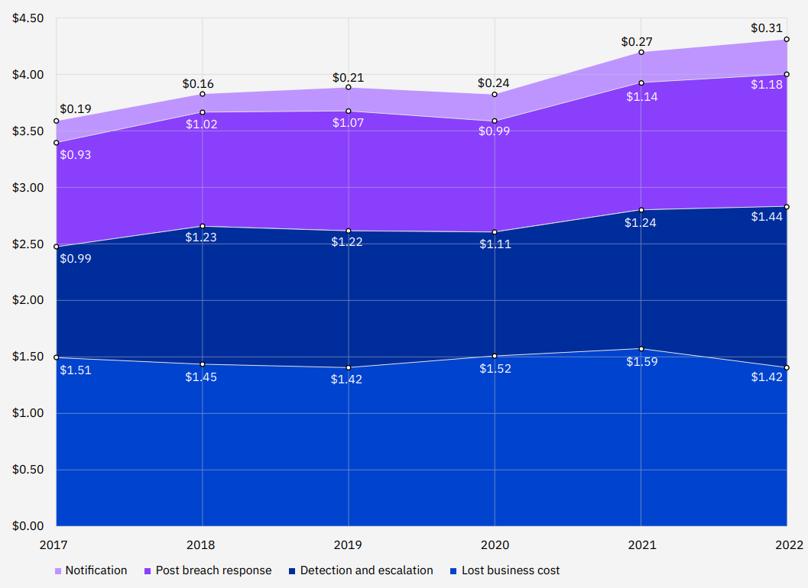

The implications of cybersecurity breaches can be severe for companies and society. Cyber-attacks can result in significant financial losses, reputational damage, and legal sanctions. Additionally, the loss of sensitive information can lead to identity theft, fraud, and other criminal activities. Society as a whole may suffer from disruptions to critical infrastructure and services, and the erosion of trust in digital systems. To mitigate these risks, organizations must continue to invest in robust cybersecurity measures and also regularly update software and firmware, create strong and unique passwords, and being vigilant for signs of suspicious activity.

# **Decentralized Control for Greater Cyber Resilience**

The evolution of blockchains or distributed ledger technology has been likened to the early stages of the internet, with many experts commenting on its potential to disrupt several industries, such as public sector, healthcare, manufacturing, energy, and especially financial services. It is believed that blockchains will become the core of the financial industry and will provide a new fabric for the industry.

To maintain confidentiality, organizations using blockchain must ensure that only authorized parties can access the relevant data. Protecting access to the blockchain network is essential for data security, especially in private blockchains. Authentication and authorization controls are necessary to prevent unauthorized access to the data. Some blockchain implementations now provide data encryption and access control measures to address confidentiality and access control issues. Full encryption of blockchain data ensures that data is not accessible to unauthorized parties during transmission, particularly over untrusted networks.

When it comes to network access control, private blockchains require appropriate security measures while public blockchains allow anyone to access the network upon downloading the software. Relying solely on existing internal security layers is not sufficient as attackers can still gain access to the network, making it important to implement security controls at the application level. Organizations should also consider how to deal with uncommunicative or intermittently active nodes within their blockchain network architecture. To protect their assets, organizations must assess the level and type of cyber risks that are acceptable and implement a cybersecurity program with well-articulated performance metrics and accountability measures. Blockchain technology offers advanced security controls, such as public key infrastructure (PKI), for authentication, authorization, and encryption. If blockchain is widely adopted, security controls must be implemented to protect data access and prevent it from becoming a high-priority target for attackers. [11]

It is possible to fully encrypt data blocks on a blockchain network, which ensures confidentiality if the latest encryption standards are followed. The use of end-to-end encryption is also important for data access control, as only authorized individuals with private keys can decrypt the data. Blockchain users often store their private keys in a secondary location, which poses a high risk of theft. Organizations should implement suitable key management procedures, like using key vaults with Hardware Security Modules. Cryptographic algorithms used for public/private key generation rely on integer factorization problems, which are difficult to break with current computing power. However, advances in quantum computing could potentially compromise the security of blockchain networks in the future, so planning for quantum-resistant cryptography is important. It's also important for organizations to develop secure key governance practices, as network access management in enterprise and global organizations is inherently challenging.

The use of blockchain technology provides users with confidence that the information stored on the ledger is authentic due to its secure nature. Unlike traditional databases, blockchain technology is difficult to tamper with because of its decentralized structure and use of sequential hashing and cryptography. Organizations using blockchain technology can be assured of the integrity and accuracy of their data. In addition, consensus model protocols associated with the technology require agreement from a majority of users before any transaction can be added to the platform, further enhancing the security of the data. To prevent ledger splitting in the event of a cyber-attack, organizations can implement measures such as monitoring nodes for suspicious behavior, such as a sudden increase in processing power and a higher volume of transactions.

When it comes to preserving the unchangeable nature of blockchain data, the compatibility of this technology with data protection laws must be taken into account. Finding ways to uphold the right to be forgotten in a technology that inherently prevents deletion poses a significant challenge, but there are a number of possible solutions. One approach is to encrypt personal data stored within the system, which can be made inaccessible by forgetting the corresponding keys. Another option is to leverage the ability of blockchain to provide a permanent record of transactions by storing only the hash of the transaction within the system, while the transactions themselves remain outside of it. This allows for the erasure of transactions, leaving behind only residual evidence of forgotten information on the blockchain.

Organizations using public or private blockchains can easily identify the corresponding party for each transaction by tracing back to a specific timestamp, as each transaction is digitally signed. This feature of the blockchain provides a high level of information security by ensuring non-repudiation, which means that it is impossible to duplicate the authenticity of someone's signature on a file or a transaction. Because every transaction is cryptographically associated with a user, any fraudulent transaction or tamper attempts can be detected, which increases the reliability of the system. Each new transaction added to a blockchain will change the global state of the ledger, resulting in a fully traceable history log that provides organizations with transparency and security over every interaction. This technology's audit capability provides entities with an extra level of reassurance that the data is authentic and has not been tampered with from a cybersecurity perspective.

The increase in cyberattacks aimed at technology services is a recent trend, with Distributed Denial of Service (DDoS) attacks being one of the most common types. This type of attack can result in significant disruptions to internet services, leading to losses for businesses. Despite being a distributed platform, blockchains can still be targeted by DDoS attacks, which can be expensive and require protective measures at both the network and application levels. Experts predict that these attacks will become increasingly common and may even strain global internet infrastructure. Although blockchain solutions are decentralized and durable, high availability is crucial, and DDoS attacks remain a significant threat. The distributed design of blockchains removes the risk of IP-based DDoS attacks causing disruptions, as the ledger data remains available through other nodes in the network. Additionally, the decentralized nature of blockchains resolves the Byzantine General's problem. Bitcoin has been the most tested and trusted platform, successfully resisting cyber-attacks for over seven years. Even when a DDoS attack impacts some nodes, data remains accessible through other nodes in the network thanks to the distributed architecture of blockchain infrastructure.

The platform's resilience is due to its peer-to-peer design and the numerous nodes that operate within the network in a continuous and distributed manner. Public and private blockchains consist of multiple nodes, enabling organizations to render an attacked node redundant and continue business as usual. Even if a large portion of the blockchain network is under attack, it can continue to operate since the technology is distributed.[12]

# **Automating Vulnerability Assessment and Management**

As the pandemic has accelerated digital transformation, new risks and opportunities have emerged. For many, their security effectiveness is hindered by organizational complexity and outdated infrastructure and support processes. Short-staffed teams face data overload from disparate sources and a lack of valuable insights, which can challenge even the most capable teams. With fewer resources, how can security leaders improve efficiency and productivity without burning out their staff? According to the IBM Institute for Business Value, investing in AI and automation can help solve these issues. As cyberattacks become more sophisticated, AI technologies such as natural language processing and machine learning are being used to help under-resourced security operations analysts stay ahead of the threats. By curating threat intelligence from a vast number of sources, these technologies can provide rapid insights that cut through the noise and reduce response times.[13]

The field of artificial intelligence (AI) encompasses various technologies that are used to create systems that can learn, reason and make decisions similar to humans, but more quickly and accurately. These systems can be utilized in various fields such as finance, medicine, and tracking disease outbreaks. AI can also use blockchain technology to enhance security for users and stakeholders, while still allowing access to data without taking control or ownership of that data. Integrating AI and blockchain can provide incentives for creating an integrated dataset that could benefit blockchain partners, while still maintaining privacy for customers and stakeholders. Furthermore, incorporating privacy-related AI functionality in blockchain network design can help in maintaining information security and personal data privacy, thereby enhancing security for users and stakeholders.[14]

AI technologies are changing security operations in four primary ways, including using machine learning to identify patterns and refine performance, using reasoning tools to enhance data analysis and predict new threats, utilizing natural language processing to improve threat intelligence and knowledge resources, and utilizing automation to orchestrate time-intensive tasks and improve response times. Adopting AI-powered automation increases flexibility and operating speed. AI's ability to continuously learn and analyze relationships between threats allows it to identify and remediate risks quickly, reducing the burden on human analysts. By consolidating data and automating response actions, AI provides faster, more effective incident analysis and remediation. AI also offers cognitive insights, contextual analytics, and benchmarking to make sense of security events, protecting endpoints, users, apps, and data from a single platform. Lastly, AI can help combat alert fatigue and reduce false positives, saving valuable time and ensuring business continuity by blocking ransomware and zero-day attacks.[15]

**Table 5.1:** Role of AI & Blockchain in User Privacy[9]

|  |  |
| --- | --- |
| **User Security** | * Detection of malicious attacks * Enhanced cryptographic capabilities |
| **System Security** | * Users have control over the data they choose to share. * Established permissions can be enforced through the use of smart contracts. |
| **Datasets** | * Enhanced protection of personal identity and metadata * Cleaner and more precise data quality |
| **AI Models** | * Increased diversity and volume of data * Enhanced accuracy and validity of models and data * Careful selection of hypotheses * Ethically obtained and permissioned data. |

The table outlines how the combination of AI and blockchain can protect and enhance user privacy. By detecting attacks, sharing permissions, and using smart contracts, the combination can improve system security. Additionally, it can improve user security by improving identity management and data. The combination can also help to enhance the AI models by using more diverse and valid data that is ethically sourced, and by constructing better hypotheses.

Combining computational intelligence (CI) and blockchain systems can enhance system security and protect the privacy of personal data. CI, based on soft computing methods, can improve cryptographic functionality and ciphers, making it more difficult for cyber hackers to compromise systems. Furthermore, AI algorithms can be integrated with blockchain to detect attacks by monitoring the chain's activity. Additionally, participants can have control over their data, deciding with which parties and for what purposes their data is shared. This "opt-in" approach ensures that personal data is used in ways that align with the owner's intentions. Smart contracts can be used to enforce rules regarding data use and govern the granting and rescinding of participant data, increasing privacy protection. The quantity and variability of data available in blockchain networks can be larger than single-company databases, providing more significant datasets for analysis. Additionally, data obtained from blockchain ledgers is cleaner, more accurate, and more ethically sourced, providing developers and users with increased confidence in the regulations. Improved hypotheses can be developed because designers must obtain participant permission and develop clear designs that define the analyses to be performed. Using ethically sourced and governed data, AI models can generate actionable results within predefined ethical and regulatory limits.[14]

# **Obstacles in The Integration of AI & Blockchain in Cybersecurity**

Integrating blockchain and AI in cybersecurity has the potential to create a more secure and resilient system. However, there are several challenges that need to be overcome for this integration to be successful.

One of the major challenges is the complexity of the technology itself. Blockchain and AI are both complex systems and integrating them together can create even more complexity. This complexity can make it difficult to create a cohesive system that is easy to manage and maintain.

Another challenge is the lack of standardization in the industry. There are currently no established standards for integrating blockchain and AI in cybersecurity, which can create confusion and make it difficult for organizations to implement these technologies effectively.

Smart contracts provide a large surface area for attack, making them vulnerable to hacking and other malicious attacks. An attack on one smart contract could potentially have a domino effect on other parts of the blockchain platform, including the language and the implementation of other contracts. One example of a vulnerability in smart contracts leading to an attack on the blockchain platform occurred during the DevCon 2 event in Shanghai. A Distributed Denial of Service (DDoS) attack exploited a vulnerability in the Go-based Ethereum client’s smart contract implementation, which prevented miners from mining further blocks. This incident highlighted the potential consequences of a single vulnerability in a smart contract, as it affected the entire Ethereum network.[16]

Additionally, there are concerns around data privacy and security. While blockchain can help to secure data by providing a tamper-proof ledger, AI may need access to sensitive data in order to function effectively. This can create a potential security risk, as bad actors could try to exploit vulnerabilities in the AI system to gain access to this data.

The quality and accuracy of the data entered into a blockchain is crucial to the integrity of the blockchain. While blockchain technology can provide a secure and tamper-proof way of storing data, it does not guarantee the quality of the data being entered. The quality of the data is the responsibility of the organizations inputting the data, and if the data being entered is of low quality or inaccurate, it can compromise the integrity of the blockchain.

One of the biggest vulnerabilities in the blockchain framework is outside the framework in the "trusted" oracles. Oracles are systems that provide information to the blockchain, and a corrupted oracle can potentially cause a domino effect across the entire network. An attack on an oracle could either be direct or indirect via third parties connected to the oracle. Oracles result in untrusted data entering a trusted environment, so organizations may need to consider using multiple oracles to increase the trust in the integrity of the data entering the blockchain from the oracle.

Another challenge is the scalability of the technology. Both blockchain and AI require significant computing power, which can make it difficult to scale these systems effectively. As the amount of data processed by these systems increases, the computing power required to maintain the system also increases, which can lead to issues with latency and slow processing speeds.

While blockchain technology is designed to be decentralized and resistant to single points of failure, it is not immune to external events that could impact the network as a whole. For example, a global internet outage or other catastrophic event could disrupt the operation of even the most distributed public blockchain networks like Bitcoin or Ethereum. Private blockchain networks with a lower number of nodes are particularly vulnerable to such events, as they may not have the same level of distribution and resiliency as larger networks.[17]

The blockchain network is not immune to threats, despite its perceived resilience. Attackers have exploited different vulnerabilities in blockchain platforms since 2008. In 2014, a bug that affected the Bitcoin network called transaction malleability led to an attack that impacted users' experience. Similarly, in 2016, an attacker exploited smart contracts on Ethereum to create an overflow that slowed down the network's validation of transactions. This resulted in the creation of a hard fork to address the issue. Operational resilience is essential, and regulators need to be involved to ensure that a governance and control framework is in place to manage the risks. Deloitte's Asia Pacific Investment Management Leader, Jennifer Qin, emphasizes that for blockchain to be commercially viable and adopted by businesses and governments, it must comply with regulatory requirements and business customs. Deloitte's Director at the Risk Advisory practice, Suchitra Nair, further emphasizes that blockchain's operational resilience is a crucial focus area for regulators and needs to be tested and demonstrated by firms to gain regulatory assurance.[12]

Finally, there are regulatory challenges that need to be addressed. As blockchain and AI become more prevalent in cybersecurity, there may be new regulatory frameworks put in place to govern their use. This can create additional challenges for organizations that are trying to integrate these technologies into their existing cybersecurity systems.

Overall, while there are significant potential benefits to integrating blockchain and AI in cybersecurity, there are also several challenges that need to be overcome. Organizations will need to carefully consider these challenges and develop strategies for effectively integrating these technologies into their existing cybersecurity systems.

# **Future Scope & Conclusion**

The integration of blockchain and AI in the field of cybersecurity has the potential to revolutionize how organizations approach data security. Despite the challenges mentioned earlier, the use of blockchain to create secure and transparent data storage, combined with AI's ability to detect and respond to threats, can offer a highly effective solution.

In the future, we can expect to see increased adoption of blockchain and AI technology in cybersecurity. With the rise of the Internet of Things (IoT) and the increasing amount of sensitive data that is being generated, the need for secure and reliable systems will become even more critical. Blockchain and AI can provide the security, scalability, and transparency that these systems require.

As technology advances, we can also expect to see more sophisticated uses of blockchain and AI in cybersecurity. For example, machine learning algorithms could be used to analyze network behavior and detect potential threats, while smart contracts could be used to automatically respond to those threats. The combination of these two technologies could provide a highly automated and effective cybersecurity system.

Ultimately, the integration of blockchain and AI in cybersecurity is a promising field with great potential. While there are certainly challenges to be overcome, the benefits of a secure and transparent system are significant. As the technology advances, we can expect to see new and innovative uses of blockchain and AI to create highly effective cybersecurity systems. It is clear that the combination of these two technologies is poised to play a significant role in the future of cybersecurity.

# **Acknowledgement**

We would like to express our gratitude to Jain (Deemed-to-be) University, Bangalore for providing us with the resources and support necessary to complete this review paper. Their contribution has been invaluable, and we are grateful for the opportunities and experiences that have been provided to us.

# **References**

[1] S. Sadik, M. Ahmed, L. F. Sikos, and A. K. M. Najmul Islam, “Toward a Sustainable Cybersecurity Ecosystem,” *Computers 2020, Vol. 9, Page 74*, vol. 9, no. 3, p. 74, Sep. 2020, doi: 10.3390/COMPUTERS9030074.

[2] F. Muheidat and L. Tawalbeh, “Artificial Intelligence and Blockchain for Cybersecurity Applications,” pp. 3–29, 2021, doi: 10.1007/978-3-030-74575-2_1.

[3] K. Kaushik, “Blockchain Enabled Artificial Intelligence for Cybersecurity Systems,” *Studies in Big Data*, vol. 111, pp. 165–179, 2022, doi: 10.1007/978-3-031-05752-6_11/COVER.

[4] “2022 Cyber Security Statistics: The Ultimate List Of Stats, Data & Trends | PurpleSec.” https://purplesec.us/resources/cyber-security-statistics/ (accessed Feb. 17, 2023).

[5] “Cybersecurity in the Remote Work Era - A Global Risk Report,” 2020.

[6] F. Xiaohua, C. Marc, E. Elias, and H. Khalid, “Artificial Intelligence and Blockchain for Future Cyber Security Application,” *Proceedings - 2021 IEEE International Conference on Dependable, Autonomic and Secure Computing, Pervasive Intelligence and Computing, Cloud and Big Data Computing and Cyber Science and Technology Congress, DASC/PiCom/CBDCom/CyberSciTech 2021*, pp. 802–805, 2021, doi: 10.1109/DASC-PICOM-CBDCOM-CYBERSCITECH52372.2021.00133.

[7] “What do AI, blockchain and GDPR mean for cybersecurity?” https://www.abajournal.com/magazine/article/ai_blockchain_gdpr_cybersecurity/?utm_source=internal&utm_medium=web (accessed Feb. 10, 2023).

[8] G. Rathee, C. A. Kerrache, and M. A. Ferrag, “A Blockchain-Based Intrusion Detection System Using Viterbi Algorithm and Indirect Trust for IIoT Systems,” *Journal of Sensor and Actuator Networks*, vol. 11, no. 4, Dec. 2022, doi: 10.3390/JSAN11040071.

[9] S. Heister, K. Yuthas, S. Heister, and K. Yuthas, “How Blockchain and AI Enable Personal Data Privacy and Support Cybersecurity,” *Blockchain Potential in AI*, Mar. 2021, doi: 10.5772/INTECHOPEN.96999.

[10] IBM Security, “Cost of a Data Breach Report 2022,” 2022. Accessed: Feb. 17, 2023. [Online]. Available: https://www.ibm.com/downloads/cas/3R8N1DZJ

[11] Sarvesh Tanwar, Sumit Badotra, and Ajay Rana, *Machine Learning , Blockchain , and Cyber Security in Smart Environments*. 2022. Accessed: Feb. 16, 2023. [Online]. Available: https://www.routledge.com/Machine-Learning-Blockchain-and-Cyber-Security-in-Smart-Environments/Tanwar-Badotra-Rana/p/book/9781032146393

[12] D. Dalton and L. Kehoe, “Written by the Deloitte EMEA Grid Blockchain Lab with insights from Deloitte global cyber SMEs from members firms including For more information please contact.” [Online]. Available: http://uk.businessinsider.com/world-economic-forum-potential-of-blockchain-in-financial-services-2016-8

[13] Gerald Parham, “4 Ways AI Capabilities Transform Security,” *SecurityIntelligence*, Aug. 25, 2022. https://securityintelligence.com/posts/ai-capabilities-transform-security/?c=Artificial%20Intelligence (accessed Feb. 17, 2023).

[14] F. Muheidat and L. Tawalbeh, “Artificial Intelligence and Blockchain for Cybersecurity Applications,” pp. 3–29, 2021, doi: 10.1007/978-3-030-74575-2_1.

[15] “Artificial Intelligence (AI) for Cybersecurity | IBM.” https://www.ibm.com/in-en/security/artificial-intelligence (accessed Feb. 17, 2023).

[16] T. Choithani, A. Chowdhury, S. Patel, P. Patel, D. Patel, and M. Shah, “A Comprehensive Study of Artificial Intelligence and Cybersecurity on Bitcoin, Crypto Currency and Banking System,” *Annals of Data Science*, pp. 1–33, Sep. 2022, doi: 10.1007/S40745-022-00433-5/TABLES/2.

[17] T. M. Fernández-Caramés and P. Fraga-Lamas, *Advances in the Convergence of Blockchain and Artificial Intelligence*. IntechOpen (www.bod.de), 2020.